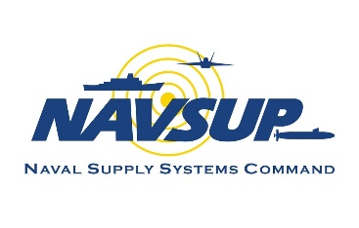

**OP Drumbeat**

**January 2025**

**Supply Corps Team,**

**I heard your feedback in the summer community survey. For those missing the OP Monthly, we are adding a newsletter-like version into the rotation on a quarterly basis. The shorter OP Drumbeats will include a TEAM’s call, while the longer version allows us to publish more in-depth content. This month’s focus is all about board guidance. Topics include the FY-26 Promotion Selection Board zones, FY-26 Supply Corps Community Brief, Oral Board guidance, updates on accessions, the sunset of an Additional Qualification Designation (AQD)/Subspecialty (SUBSPEC), Career Counselor highlights, and more. As always, please submit suggestions to the Supply Corps Career Counselor (SCCC) for future topics of interest.**

**FY-26 Promotion Selection Boards**

**Below are the senior in-zone and junior in-zone officers eligible for consideration for each promotion board, the board convening date, and deadline for submission of letters to the board. The FY-26 Supply Corps community and merit reorder briefs are included for easy reference. We look forward to discussing these more at length when we visit your area for the roadshow.**

**FY-26 Promotion Zones (AC)** [NAVADMIN 248/24](https://www.mynavyhr.navy.mil/Portals/55/Messages/NAVADMIN/NAV2024/NAV24248.txt?ver=fTQHZXrVsSWt55jXrb7nog%3d%3d)

|  |  |  |  |  |
| --- | --- | --- | --- | --- |
| **Rank** | **SR/JR IZ Lineal #** | **SR/JR IZ Name** | **Board Date** | **Letters to the Board Due Date** |
| CAPT | 2559875 | MCCARTHY SCOTT MATTHEW | 11 FEB 25 | 31 JAN 25 |
| 2579600 | LEASE QUENTIN EUGENE |
| CDR | 4712200 | HYLTON HENSLEY GEORGE | 5 MAY 25 | 24 APR 25 |
| 4802300 | KING DARTANYON RECARDO |
| LCDR | 11216600 | LEWISSIDNEY SHEROD LAMAR | 5 MAY 25 | 24 APR 25 |
| 11723000 | TORRESGUEVARA MARIA A |

FY-26 Promotion Zones (FTS) [NAVADMIN 257/24](https://www.mynavyhr.navy.mil/Portals/55/Messages/NAVADMIN/NAV2024/NAV24257.txt?ver=X2ZRWZpz5qFNN0GB4L825Q%3d%3d)

|  |  |  |  |  |
| --- | --- | --- | --- | --- |
| **Rank** | **SR/JR IZ Precedence** | **SR/JR IZ Name** | **Board Date** | **Letters to the Board Due Date** |
| CAPT | 26325100 | BOYD DAVID ANDREW III | 4 MAR 25 | 21 FEB 25 |
| 26449400 | ENGELS COLIN CLYDE |
| CDR | 37194850 | ROAN PAUL ALLAN | 4 MAR 25 | 21 FEB 25 |
| 38293300 | GOFF REBECCA ANN |
| LCDR | 43578900 | DUNCAN IAN J | 27 MAY 25 | 16 MAY 25 |
| 44023000 | PENDOCK ANDREW WILLIAM |

FY-26 Promotion Zone (RC) [NAVADMIN 257/24](https://www.mynavyhr.navy.mil/Portals/55/Messages/NAVADMIN/NAV2024/NAV24257.txt?ver=X2ZRWZpz5qFNN0GB4L825Q%3d%3d)

|  |  |  |  |  |
| --- | --- | --- | --- | --- |
| **Rank** | **SR/JR IZ Precedence** | **SR/JR IZ Name** | **Board Date** | **Letters to the Board Due Date** |
| CAPT | 26041000 | BOLL P. T. | 4 MAR 25 | 21 FEB 25 |
| 26207500 | CHEETHAM D. S. |
| CDR | 36998000 | HOGAN J.T. | 4 MAR 25 | 21 FEB 25 |
| 37266000 | CARLTON C. H. |
| LCDR | 43689100 | TARQUINIO D. L. | 27 MAY 25 | 16 MAY 25 |
| 44035600 | NEIBUHR M. G. |

[**FY-26 Supply Corps Community**](https://www.mynavyhr.navy.mil/Portals/55/Boards/Active%20Duty%20Officer/documents/FY26_Promotion_Board_Materials/FY26_AC_Staff_Community_Briefs.pdf?ver=fVjkJUxWWQ3Jqr1TALht0w%3d%3d) **Brief**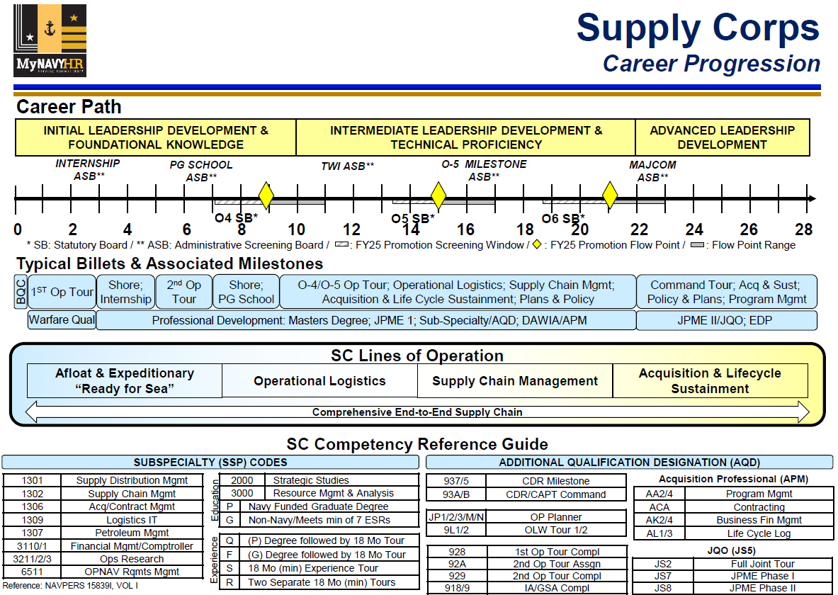

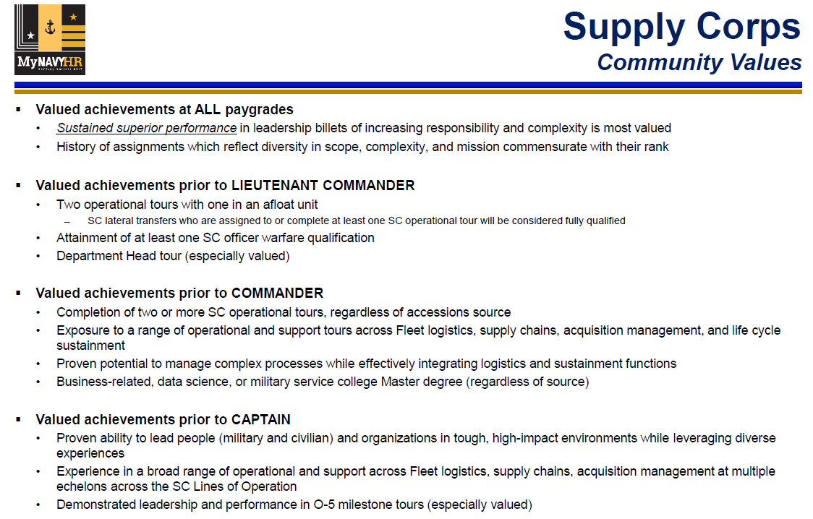

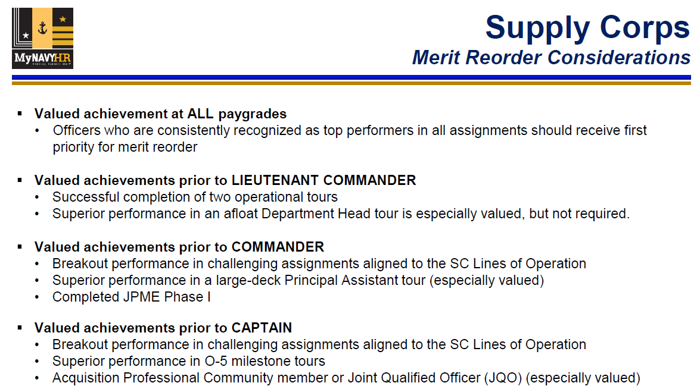

**Oral Board Administration and Preparation Guidance**

**Commander milestone oral board season is approaching, and we will send more information to eligible officers within the next couple of weeks. We asked a few of our Major Command (MAJCOM) Commanding Officers to provide insight and advice as you prepare for the administrative screening board and hope you find it helpful. Thank you CAPT Bill Barich, CAPT Matt Bolls, and CAPT Shannon Walker for this valuable contribution and perspective.**

**What should officers expect from a 2D1 board?**

**Expect variation and be prepared for it; no two boards are alike. Expect the board members to review your record in advance and potentially ask 2-3 primary questions per board member (secondary questions may occur based on your initial answers). Given you are preparing to potentially lead a milestone level organization and will be the senior Supply Officer, questions about leadership, perspective, community, potential scenarios as well as priorities of our Navy leadership (SECNAV, CNO, Chief of SC) are all fair game.**

**How should a Commander (CDR)/CDR (sel) prepare for the 2D1 board?**

**Whether they know it or not, officers are preparing for their 2D1 board throughout their careers. This board is the culmination of many years of experience. The leadership they’ve observed as junior officers, the mentorship they received from their Chief’s mess, and the challenges and successes experienced leading Sailors through difficult times. It’s the collective experience that prepares officers for the board.**

**A common expression in our business is that of the metaphorical “sea-bag.” We’re issued one when we first swear the oath and then carry it throughout our careers. Through observation and experience, we fill this bag with the best practices and lessons learned that shape who we become as Naval Officers. To continue to the metaphor, the 2D1 board is simply an inspection of that sea-bag. We look to see what you’ve learned, how it has shaped you, and how you will use it in a position of increased responsibility and expectations.**

**Leading up to the board, officers should set aside time for introspection and schedule office calls with all of the trusted mentors who enabled them to be selected for CDR in the first place. Understand yourself and leverage the guidance of those who have gone before you.**

**How is the Oral Board administered and what advice do you have for future Fleet Logistics Center (FLC) COs who will chair these boards?**

**Oral Board boards consist of at least one Captain (CAPT) who has completed or is in a Supply Corps CAPT MAJCOM assignment and one CAPT or CDR who has completed or is in a CDR Milestone assignment. Additionally, a senior civilian (GS-15 and above) should serve on the oral board when available. Board members must not be in the same chain of command as the officer going before the board.**

**All candidates will contact their regional FLC Executive Officer (XO) as designated by OP to schedule their milestone board. Active communication is key to a successful milestone board. Each member on the board will receive the candidate’s nomination letter, current biography, Performance Summary Record, Officer Summary Record, and Officer Data Card for review. Ensure your record is updated and correct!**

**Oral boards can be administered in person (recommended) or virtually and will usually last an hour. Once the board is completed, the chairperson will report the board’s finding as eligible or not eligible, with a letter to PERS-4412.**

**For future FLC COs who will chair these boards, be available, be consistent, and be fair. Recommend reviewing the candidates’ record well in advance, discussing expectations of board members, and reviewing sample board questions well in advance. While some level of technical expertise is expected by this point in the candidates’ career, this should not be the focus. A blend of leadership qualities, community awareness, and decision-making acumen should prevail.**

**What is the role of the ED/GS-15 as a board member?**

**The civilian ED/GS-15 role brings a critical and necessary perspective to the 2D1 board. These senior leaders are some of the most experienced and seasoned leaders in our community. Their input is invaluable on a board enabling CDRs to be eligible for Milestone.**

**While their active duty counterparts PCS every 2-3 years, our civilian leaders maintain consistency across DoD. Their longevity, and ability to observe many different officers over the course of their careers afford them a unique perspective on identifying leaders ready for the challenge of a Milestone tour. By the time a person is eligible for an Executive Director, or senior GS-15 position, they will have experienced countless active duty leaders. Additionally, many of these EDs/GS-15s were, themselves, senior Supply Corps officers, thus giving them an additional lens with which to evaluate candidates. This perspective is critical to an effective 2D1 board.**

**Additionally, because the 2D1 board is a once in a career event, and serves not only as a discriminator for CDR Milestone, but also Major Command (later in an Officer’s career), its critical officers are evaluated early for the qualities required to make them successful at the next level. Further, many of our MAJCOMs are comprised largely of civilians, making the discerning eye of our senior GS, even more critical.**

**What advice would you offer to junior officers who want to develop and grow into future Milestone leaders?**

**Reminder that the oral board is not just an hour interview, but an evaluation of your career entirety and your future potential. Periodic record reviews and mentorship engagements are just one step in becoming prepared for milestone. Be hungry to learn and develop, seek opportunities to build the community, and strengthen the Navy. View every challenge as an opportunity to learn and grow. Equip yourself with diverse leadership experiences and perspectives essential for a Milestone-selected leader. Strive to become an indispensable asset to the Supply Corps.**

**Supply Corps Accessions and Tour Length Impacts**

**Supply Corps accessions are at an all-time high. The Navy Supply Corps School is currently at maximum capacity and the next few classes are forecasted to remain high. The students are eager and ready to get out to the Fleet and while high accessions are great; it’s impacting timing and rotation to keep pace. As a result, officers can expect their Projected Rotation Dates (PRDs) to shift from 30 to 24 months. Earn your warfare device as quickly as possible and be prepared to enter your detailing window based on rolling at 24-months. Additionally, those on their first shore duty assignment can expect to rotate between 24-36 months to fill Lieutenant (LT) operational assignments. These adjustments are necessary to accommodate the high accessions and compensate for the current LT shortage.**

**As these accessions progress through the career timeline, tour lengths are expected to return to normal and align to the career progression published in the community brief. If you have any questions about timing at your current command, please reach out to your detailer.**

**Transportation Subspecialty Code (1304) Disestablishment**

**As of December 2024, the Navy disestablished the 1304, Transportation Subspecialty Code.  This is a result of the Transportation Curriculum disestablishment at Naval Postgraduate School and was subsumed into the Supply Chain Management Curriculum (1302).**

* **This change resulted in a small number of billets (10) having the 1304 Subspecialty Code removed.**
* **There will be no future chance to earn the 1304 Subspecialty Code, but those who have it in their record will retain it.**

**The Supply Corps will now use the 920 AQD to track experience gained in Transportation Management. If your experience meets the below criteria, you many apply for the 920 AQD via the SCCC.**

* **Broad general experience in the transportation area through a series of tours in various segments or served in a transportation internship program or policy billet at USTRANSCOM, AMC, SDDC, MTMC, NAVSUP, or a major staff.**

**Orders Release Posture**

**Based on the Continuing Resolution and current funding levels, Navy Personnel Command is releasing orders with estimated date of departure through May 2025. We will publish the current orders release posture in future OP Drumbeats and on each detailer’s page as billet lists are updated. Please reach out to your detailer if you have questions about your pending orders.**

**Career Counselor Highlights**

**Be on the lookout for important reminders from OP, including the Training with Industry (TWI), Internship, and Postgraduate School Flash. These Flashes will include general information and application deadlines.**

**CAPT Dena B. Risley**

**Director, Supply Corps Personnel**

# Important Links

**MyNavy HR links:**

* [[Supply Corps Career Counselor](https://www.mynavyhr.navy.mil/Career-Management/Detailing/Officer/Pers-44-Staff-RL/Supply-Corps-Officer/Career-Counselor/" \o "MyNavyHR Career Counselor)](https://www.mynavyhr.navy.mil/Career-Management/Detailing/Officer/Pers-44-Staff-RL/Supply-Corps-Officer/Career-Counselor/)
* [CAPT Detailer](https://www.mynavyhr.navy.mil/Career-Management/Detailing/Officer/Pers-44-Staff-RL/Supply-Corps-Officer/Captain-Detailer/)
* [CDR Detailer](https://www.mynavyhr.navy.mil/Career-Management/Detailing/Officer/Pers-44-Staff-RL/Supply-Corps-Officer/CDR-Detailer/)
* [LCDR Detailer](https://www.mynavyhr.navy.mil/Career-Management/Detailing/Officer/Pers-44-Staff-RL/Supply-Corps-Officer/LCDR-Detailer/)
* [LT Operational & PG School Detailer](https://www.mynavyhr.navy.mil/Career-Management/Detailing/Officer/Pers-44-Staff-RL/Supply-Corps-Officer/Operational/)
* [LT & LTJG Detailer](https://www.mynavyhr.navy.mil/Career-Management/Detailing/Officer/Pers-44-Staff-RL/Supply-Corps-Officer/LT-LTJG-Detailer/)
* [Internship](https://www.mynavyhr.navy.mil/Career-Management/Detailing/Officer/Pers-44-Staff-RL/Supply-Corps-Officer/Internship/)
* [Nominative Billets](https://www.mynavyhr.navy.mil/Career-Management/Detailing/Officer/Pers-44-Staff-RL/Supply-Corps-Officer/Nominative-Billets/)
* [2024 Supply Corps Directory (CAC-Enabled)](https://www.mnp.navy.mil/documents/34109/69231714004/2024+U.S.+Navy+SC+Directory.pdf/6e81f7c1-dedc-0ddc-7676-66dd1756e61a?t=1707759927132)
* [FY26 Board Schedule](https://www.mynavyhr.navy.mil/Portals/55/Boards/Selection/FY26%20WEB.pdf?ver=CwcoXyScUd-i4htTZYBW3Q%3d%3d)
* [FY 26 Active Duty Promotion Selection Board Zone Message (NAVADMIN 248/24)](https://www.mynavyhr.navy.mil/Portals/55/Messages/NAVADMIN/NAV2024/NAV24248.txt?ver=fTQHZXrVsSWt55jXrb7nog%3d%3d)
* [FY 26 Reserve Promotion Selection Board Zone Message (NAVADMIN 257/24)](https://www.mynavyhr.navy.mil/Portals/55/Messages/NAVADMIN/NAV2023/NAV23301.txt?ver=c9YRHVwp_bbZF6bxpTay_g%3d%3d)
* [Officer Retirements](https://www.mynavyhr.navy.mil/Career-Management/Retirement/Officer-Retirements/) / [Officer Resignations](https://www.mynavyhr.navy.mil/Career-Management/Personnel-Conduct-Sep/Officer-Resignations/)
* [Supply Corps Newsletter Summer 2024](https://public.navsup.navy.mil/public/sites/supply_corps_newsletter/pages/summer_2024)
* [Supply Corps Officer - Training, Education, Qualifications - MyNavy Portal](https://usg01.safelinks.protection.office365.us/?url=https%3A%2F%2Fwww.mnp.navy.mil%2Fgroup%2Ftraining-education-qualifications%2Fsupply-corps-officer&data=05%7C02%7Cnicholas.c.mays.mil%40us.navy.mil%7Cdfb20962af8d4e01399808dcd36051f6%7Ce3333e00c8774b87b6ad45e942de1750%7C0%7C0%7C638617657841687128%7CUnknown%7CTWFpbGZsb3d8eyJWIjoiMC4wLjAwMDAiLCJQIjoiV2luMzIiLCJBTiI6Ik1haWwiLCJXVCI6Mn0%3D%7C0%7C%7C%7C&sdata=Q%2FDmk39ZRWTN17DyHCvmduIzOUzrZmz8YMgGXTYYKh0%3D&reserved=0) (New Link)

# Contact Us

|  |  |  |
| --- | --- | --- |
| **Position** | **Name** | **E-mail** |
| Director | CAPT Dena Risley | dena.b.risley.mil@us.navy.mil |
| Director, Detailing Division | CAPT(s) Krysten Ellis | [krysten.j.ellis.mil@us.navy.mil](mailto:krysten.j.ellis.mil@us.navy.mil) |
| OP Assistant | CDR Dustin Martindale | dustin.r.martindale.mil@us.navy.mil |
| OP1 Assistant | CDR K. Matt Wall | kevin.m.wall10.mil@us.navy.mil |
| Reserve & TAR Director | CAPT Eric Gardner | eric.a.gardner5.mil@us.navy.mil |
| TAR Mgt. Branch Detailer | CDR Treven Feleciano | treven.s.feleciano.mil@us.navy.mil |
| “Pit Boss”/LCDR Detailer | CDR Long Tran | long.k.tran.mil@us.navy.mil |
| LT Operational/PG School | LCDR Michelle Coleman | michelle.m.coleman11.mil@us.navy.mil |
| LT Shore Detailer | LCDR Winston Lamb | winston.c.lamb.mil@us.navy.mil |
| CWO/BQC/Submarine Detailer | CWO5 Jeffrey Walker | jeffrey.l.walker.mil@us.navy.mil |
| AC Career Counselor | LCDR Nicholas Mays | nicholas.c.mays.mil@us.navy.mil |
| RC Career Counselor | LCDR Chad Brown | chad.a.brown62.mil@us.navy.mil |
| Accessions/Internship Officer | LTJG Max Collins | max.d.collins3.mil@us.navy.mil |
| Director, Supply OCM | CDR Adam Hilliard | [adam.g.hilliard4.mil@us.navy.mil](mailto:adam.g.hilliard4.mil@us.navy.mil) |
| Deputy, Supply OCM | Ms. Beth Schudel | beth.r.schudel.civ@us.navy.mil |
| Director, Reserve OCM | LCDR Danica Johnson | danica.r.johnson.mil@us.navy.mil |
| Supply Corps Career Counselor Inbox: [usn.mid-south.navsuphqmech.mbx.supply-corps-cc@us.navy.mil](mailto:usn.mid-south.navsuphqmech.mbx.supply-corps-cc@us.navy.mil) | | | |

# *Supply Corps Officer Strength*

**3100 Active Component**

|  |  |  |  |  |  |
| --- | --- | --- | --- | --- | --- |
| **Paygrade** | **Authorized** | **Inventory** | **Gross Over/Under** | **Non-Distributable Inventory** | **Total Delta** |
| **O-6** | 168 | 157 | **-11** | 2 | **-13** | |
| **O-5** | 361 | 346 | **-15** | 4 | **-19** | |
| **O-4** | 535 | 513 | **-22** | 4 | **-26** | |
| **O-3** | 722 | 549 | **-173** | 10 | **-183** | |
| **O-2** | 265 | 343 | **78** | 14 | **64** | |
| **O-1** | 273 | 369 | **96** | 1 | **95** | |
| **Totals** | **2324** | **2277** | **-47** | **35** | **-82** | |

Data source: the Officer Inventory / Authorization (Tri-Color) dated 31 December 2024.

Note: Officers selected for promotion in FY25 are listed in their current rank. Officers are detailed to billets in the next higher rank, resulting in lower distributable LT inventory numbers.

**3107 Reserve Component –Training and Administration of the Reserves (TAR)**

|  |  |  |  |
| --- | --- | --- | --- |
| **Paygrade** | **Authorized** | **Inventory** | **Delta** |
| **O-6** | 9 | 8 | **-1** |
| **O-5** | 28 | 20 | **-8** |
| **O-4** | 38 | 46 | **8** |
| **O-3** | 35 | 17 | **-18** |
| **O-2** | 0 | 5 | **5** |
| **O-1** | 1 | 4 | **3** |
| **Totals** | **111** | **100** | **-11** |

**3105 Reserve Component (RC) – Selected Reserves (SELRES)**

|  |  |  |  |
| --- | --- | --- | --- |
| **Paygrade** | **Authorized** | **Inventory** | **Delta** |
| **O-6** | 52 | 51 | **-1** |
| **O-5** | 178 | 171 | **-7** |
| **O-4** | 320 | 277 | **-43** |
| **O-3** | 183 | 116 | **-67** |
| **O-2** | 82 | 78 | **-4** |
| **O-1** | 82 | 72 | **-10** |
| **Totals** | **897** | **765** | **-132** |

**3165 RC In-Training**

|  |  |  |
| --- | --- | --- |
| **Paygrade** | **Authorized** | **Inventory** |
| **O-3** | 0 | 0 |
| **O-2** | 0 | 4 |
| **O-1** | 0 | 68 |
| **Totals** | **0** | **72** |

**6510 Limited Duty Officer (LDO)**

|  |  |  |  |  |  |
| --- | --- | --- | --- | --- | --- |
| **Paygrade** | **Authorized** | **Inventory** | **Gross Over/Under** | **Non-Distributable Inventory** | **Total Delta** |
| **O-6** | 0 | 0 | **0** | 0 | **0** |
| **O-5** | 0 | 0 | **0** | 0 | **0** |
| **O-4** | 1 | 0 | **-1** | 0 | **-1** |
| **O-3** | 36 | 16 | **-20** | 0 | **-20** |
| **O-2** | 9 | 11 | **2** | 0 | **2** |
| **O-1** | 17 | 17 | **0** | 0 | **0** |
| **Totals** | **63** | **44** | **-19** | 0 | **-19** |

**7520 Food Service Warrant**

|  |  |  |  |  |  |
| --- | --- | --- | --- | --- | --- |
| **Paygrade** | **Authorized** | **Inventory** | **Gross Over/Under** | **Non-Distributable Inventory** | **Total Delta** |
| **CWO-5** | 3 | 5 | **2** | 0 | **2** |
| **CWO-4** | 10 | 11 | **1** | 0 | **1** |
| **CWO-3** | 26 | 27 | **1** | 0 | **1** |
| **CWO-2** | 19 | 20 | **1** | 0 | **1** |
| **Totals** | **58** | **63** | **5** | **0** | **5** |